**Project Development Phase**

**Sprint 3**

|  |  |
| --- | --- |
| Date | 12 November 2022 |
| Team ID | PNT2022TMID14574 |
| Project Name | AI BASED DISCOURSE FOR BANKING INDUSTRY |

**Screenshots of Sprint 3 Tasks:**

**Build Python Code:**

1. **Importing Libraries**

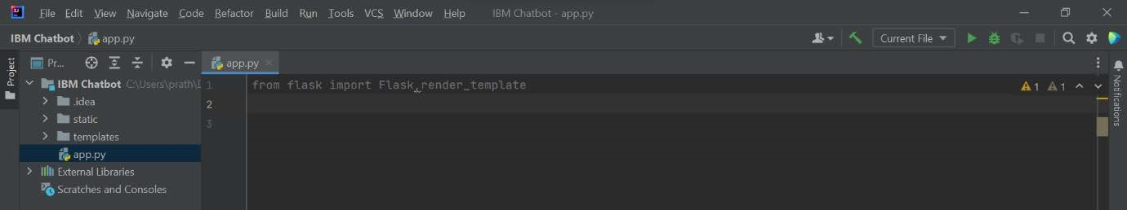

1. **Creating our flask application and loading**

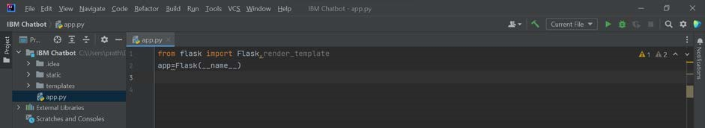

1. **Routing to the HTML Page**

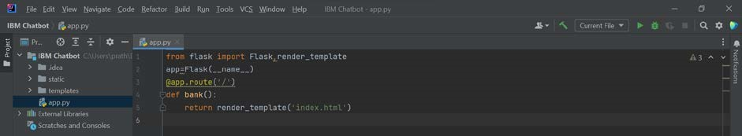

1. **Main Function**

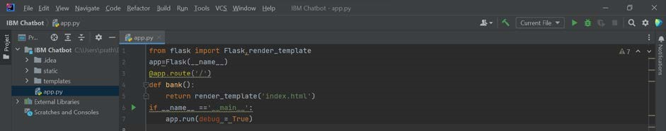

**Run the Application:**

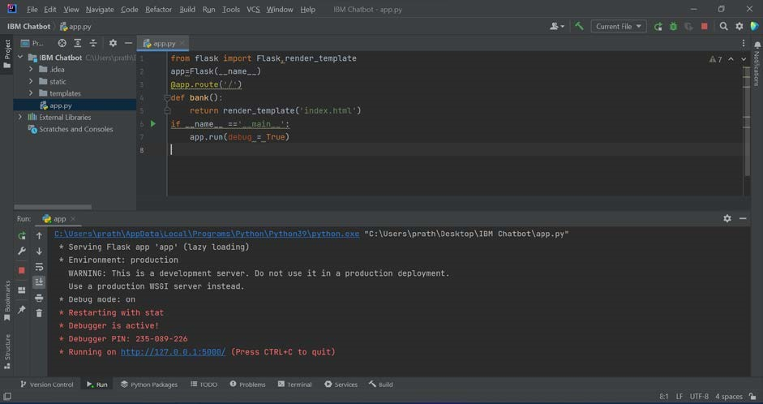

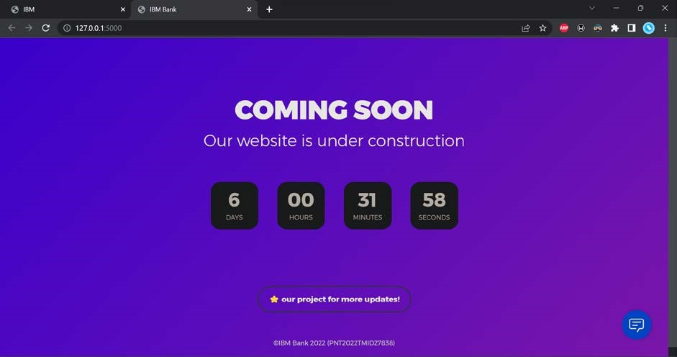

**Deploying the Flask Application on Replit:**

[**https://ibm-chatbot.prathkrish.repl.co/**](https://ibm-chatbot.prathkrish.repl.co/)

